**Java-13**

**Program Cari Dan Ubah**

**Pengantar**

Merancang Form dan membuat kode program Cari, Ubah Menggunakan Perintah SQL (Select Dan Update).

**Algoritma**

1. Rancang database dan tabel

Nama database : Matutung

Nama tabel : Mahasiswa

|  |  |  |
| --- | --- | --- |
| Nama Field | Type Data | Panjang |
| Nim | Char | 10 |
| Nama | Varchar | 50 |
| Alamat | Varchar | 50 |
| Grup | Varchar | 10 |
| Makul | Varchar | 50 |
| Nilai | Int | 11 |

1. Isi data pada tabel Sebanyak 5
2. Rancang form Simpan

Nama Java Project : medicomdarat

Nama Package : berhasil

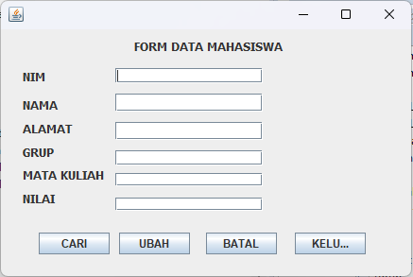Nama Form : Cari

**4.Membuat Kode Program**

Tambahkan class componen berikut ini dibawah *package (****Ketik Baris-2****)*

**import** java.sql.Connection;

**import** java.sql.DriverManager;

**import** java.sql.ResultSet;

**import** java.sql.Statement;

Deklarasikan koneksi variabel ke koneksi database setelah *public class Nama Form extends JFrame {*

**public** Connection kon;

**public** String sql = "";

**public** Statement stat ;

**public** ResultSet rs;

Ketik script program cari dibawah ini diantar script dari tombol cari **actionPerformed**

*public void actionPerformed(ActionEvent arg0) { ….. }*

**try** {

Class.*forName*("com.mysql.jdbc.Driver");

kon = DriverManager.*getConnection*("jdbc:mysql://localhost:3306/**java13**", "root", "");

sql = "select * from **toko** where **kobar**='" + **tkode**.getText() + "'";

stat = kon.createStatement();

rs = stat.executeQuery(sql);

**while** (rs.next()) {

**tkode**.setText(rs.getString("**kobar**")); **tnabar**.setText(rs.getString("**nabar**"));

**tharga**.setText(rs.getString("**harga**")); **tjumlah**.setText(rs.getString("**jumlah**"));

javax.swing.JOptionPane.*showMessageDialog*(**null**, "Data Ditemukan");

}

} **catch** (Exception e) {

javax.swing.JOptionPane.*showMessageDialog*(**null**, "Gagal Proses Cari Data "+e);

}

*Ketik script program update data dibawah ini diantar script dari tombol Update****actionPerformed***

*p ublic void actionPerformed(ActionEvent e)  { ….. }*

***try****{*

*Class.forName("com.mysql.jdbc.Driver");*

*kon = DriverManager.getConnection("jdbc:mysql://localhost:3306/****dbjava13****", "root", "");*

*sql = "update* ***toko*** *set* ***nabar****='" +****tnabar****.getText() + "',"+ "****harga*** *='" +****tharga****.getText() + "',"+ "****jumlah*** *='" +****tjumlah****.getText() + "'” + "where* ***kobar*** *='" +****TKode****.getText() + "'";*

*stat = kon.createStatement();*

*stat.execute(sql);*

***TKode****.setText("");*

***Tnabar****.setText("");*

***Tharga****.setText("");*

***Tjumlah****.setText("");*

***TKode****.requestFocus();*

*{*

*javax.swing.JOptionPane.showMessageDialog(****null****, "Update Data Sukses");*

*}*

*}****catch****(Exception ex) {*

*javax.swing.JOptionPane.showMessageDialog(****null****, "Gagal Proses Update Data "+ex);*

*}*

5.Buat Koneksi Library